Table of Contents
Copyright Information 2
Revision History 2
References 2
1. Introduction 3
2. Functional Scope 3
2.1 Login Module 4
2.2 Management Setup Module 5
2.2.1 User 5
2.2.2 Account 10
2.2.3 Settings 12
2.2.4 Assets 16
2.2.5 Tag 19
2.2.6 Agent / Agent Location 20
2.3 Transactional Module 23
2.3.1 Work Order 23
2.3.2 Dolly’s / Tractors 25
2.3.3 Mobile Interaction Module - Web Service List 26
2.3.4 Reports 28
3. Technical Scope 28
3.1.1 Technical Architecture 28
3.1.2 Technical Description 28
3.1.2.1 Login Module 28
3.1.2.2 Management Setup Module 29
3.1.2.3 Transactional Module 40
4. Out of Scope 41
5. Assumptions & Dependencies 41

Copyright Information

This document is the exclusive property of Ascent Solutions Pte Ltd. (Ascent); the recipient agrees that they may not copy, transmit, use or disclose the confidential and proprietary information in this document by any means without the expressed and written consent of Ascent. By accepting a copy, the recipient agrees to adhere to these conditions to the confidentiality of Ascent’s practices and procedures; and to use these documents solely for responding to Ascent‘s proposal.

Revision History
Please keep the latest version on top.
Ver | Change Description | Sections | Date | Author | Reviewer
1.0 | Draft document | All Modules | 28/11/2014 | Bala A | Caleb

References
Reader should read this document in conjunction with the following documents.
This document is created further to the discussion between Caleb (Ascent) and eNoah team (Bala A) on the requirements for the Atlas web app.

No | Document Name | Ver | Location

Introduction
This is a functional requirement document for the Atlas web app that is being developed by Ascent Solutions. The following sections list out the different modules and functionalities of the app and the required business rules to be applied for each of the modules.
The diagrams / screen designs mentioned in this document are not the final UI screens but just the wireframes to give an idea about how the system will look alike and to give understanding for the development team to develop the web app. This no way represents the actual UI of the web app.

Functional Scope
This document will covers list of modules in the ATLAS web application and the sub-sequent sections will provide the screen by screen information in the each module.
- Login Module
- Management Setup Module
  - User
  - Account
  - Settings
    - Access Master
    - Static codes
    - Email Template
    - Email Subscription
  - Assets
    - Dolly’s
    - Tractors
  - Tag
  - Agent / Agent Location
- Transactional Module
  - Work Order
  - Dolly’s / Tractors
- Mobile Interaction Module - Web Service List
  - Login
  - Workorder List
  - Workorder Status
  - Listing Assets
  - Photo Upload
- Reports

Login Module
System requires the user to login to access all the features and other screens within the app. The login will be validated against the database. Based on login validation user will be redirected to the landing screen, and the token Id will be generated for every successful login and will kept in session for further transaction in the login period.
Entry Criteria
User can enter the URL in the Web browser to land in the application.
UI Design
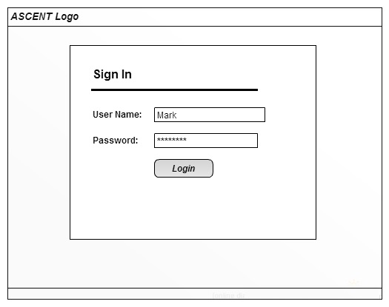
Figure 1: Login Screen
Business Rules
- The user will enter the username; account Id (default to 1 and as a backend value) and the password provided and click on the “Login” button to login within the system.
- On click of the “Login” button, the system will validate the login authentication credentials provided by the user against the credentials available in the database and on successful validation, the user is allowed to enter into the system and the menu’s will be load based ACL Configuration and token ID will be generated for further transactions.
- If the login is not successful, appropriate error messages will be displayed on screen and the user will continue to remain in the login screen until he provides the proper credentials to login.
Exit Criteria
If login successful, user will land in the User screen based on the ACL Configuration, otherwise user will remains in the same Login Screen.

Management Setup Module
This Module will be describe the core modules of systems like User, Account, Settings, Asset, Tag and Agent information in the detailed with business rules, ui screens, entry & exit criteria.

User
System will provide an option to create / update the user and user privilege based on the ACL configuration, below are the list of operation can be performed in this module.
  - User List
  - Create User
  - Update Existing User
  - Load Existing User
  - Enable / Disable User
Entry Criteria
After successful login, based on the ACL configuration system will land in this screen.
UI Screens
User Listing
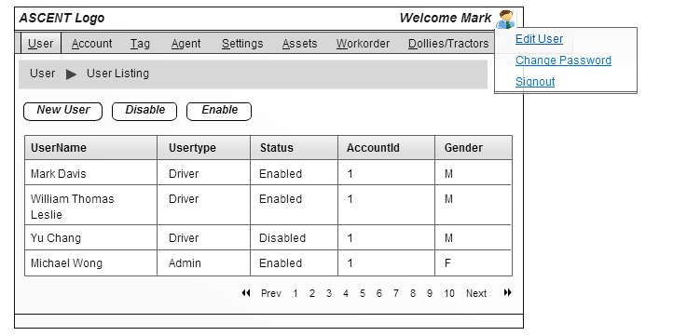
Figure 2: User Listing

New User Creation
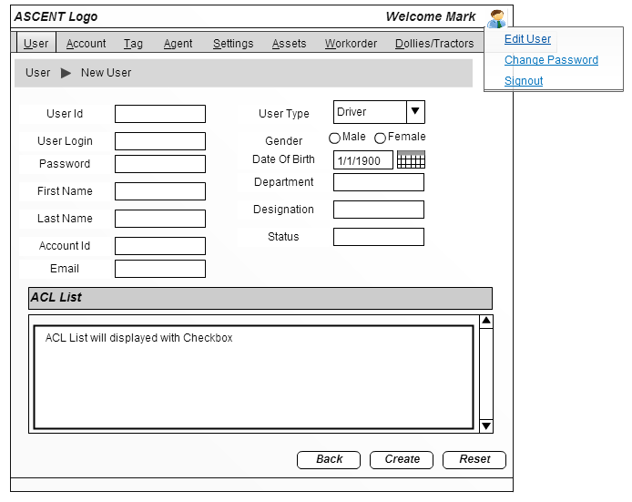
Figure 3: New User Creation
Update User
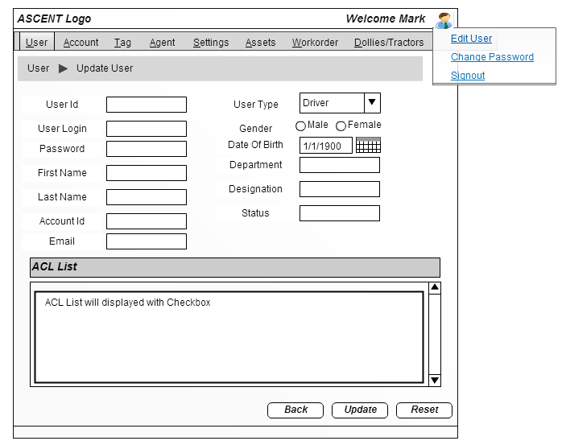
Figure 4: Update User
Enable User
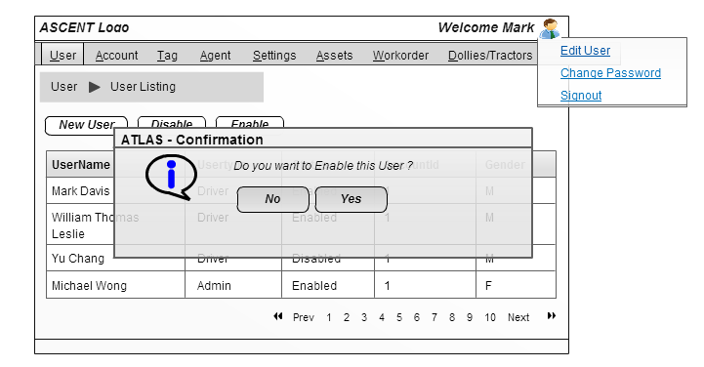
Figure 5: Enable User
Disable User
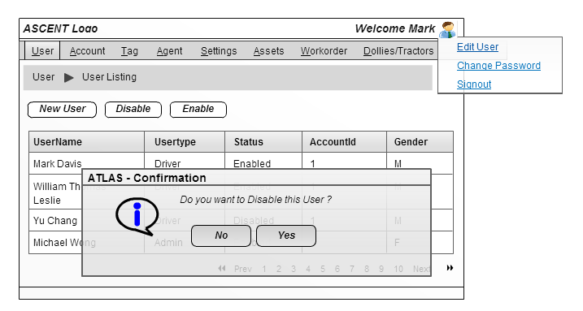
Figure 6: Disable User
Business Rules
User Listing
    - All available user list belonging to the same account which the current user is logged in will get displayed on screen. For e.g. if user “Caleb” belongs to SATS, and he logs in to the application, then all user accounts belongs to SATS account will get displayed.
    - System will check the ACL configuration to display the screen in either “Read/View” or “Edit” mode.
    - System will provide an option for the user to create a new user by clicking on the “New User” button on top of the user listing grid.
    - System will provide an option to enable the inactive user by clicking on the “Enable” button on top of the user listing grid, by default this button will be disabled in screen.
    - System will provide an option to disable the active user by clicking on the “Disable” button on top of the user listing grid, by default this button will be disabled in screen.
    - System will also provide an option to update the existing the user information by clicking the particular user information in the grid anywhere.
New User Creation
    - Once the user click on the “New User” button in the listing screen, system will redirect to the user creation screen to create a new User.
    - Once the mandatory fields are filled, the system will trigger a call to persist the new user information in the database.
    - System will validate if the user id already exists or not,
      - If YES,
        - System will trigger the update method to update the user information with the associated user id.
        - System will delete the existing the ACL configuration and persist the new ACL configuration against the user id in database.
      - If NO,
        - System will check the user login name already exist or not,
          - If YES, system will throw a user readable error message as “User Login already Exist” and will prompt the user to provide the different login name.
          - If NO, system will initiate the data persistent for User information and ACL configurations.
    - After successful user account creation, success message “User [User Login Name] created successfully” will be displayed along with the User ID.
    - System will provide an option to return back to the “User Listing” screen.
Update User
    - Once the user click on the particular user information in the grid, system will redirect the user to the “Update User” screen.
    - System will load the user information along with the existing ACL configuration based on the User Id.
    - Once the mandatory fields are filled, the system will trigger a call to update the user information in the database.
    - System will validate if the user id already exists or not
      - If YES,
        - System will trigger the update method to update the user information with the associated user id.
        - System will delete the existing the ACL configuration and persist the new ACL configuration against the user id in database.
      - If NO,
        - System will throw a user readable error message as “User ID not Exist”.
    - After successful update, success message “User [User Login Name] updated successfully” will be displayed.
    - System will provide an option to return back to the “User Listing” screen.
Enable User
    - User select the inactive username in the list and click on the “Enable” button on top of the grid to enable or activate the user account
    - Once the user clicks on the “Enable” button, the pop up screen will displayed to get the confirmation message from user to enable the deactivated user.
    - If user click YES in the confirmation popup,
      - System will initiate an update method by change the status value as “0” to enable the user.
      - System will update the status value only; specific flag (isEnabled) will be used to differentiate the normal update logic.
      - Once the status update the user listing grid will be re-loaded with the new values.
    - If user click NO in the confirmation popup,
      - System will remains in the same screen with any modification.
Disable User
    - User select the active username in the list and click on the “Disable” button on top of the grid to disable or in activate the user account
    - Once the user clicks on the “Disable” button, the pop up screen will displayed to get the confirmation message from user to disable or in activate the active user.
    - If user click YES in the confirmation popup,
      - System will initiate an update method by change the status value as “1” to enable the user.
      - System will update the status value only; specific flag (isDisabled) will be used to differentiate the normal update logic.
      - Once the status update the user listing grid will be re-loaded with the new values.
    - If user click NO in the confirmation popup,
      - System will remains in the same screen with any modification.
Exit Criteria
User can click any other menus in the screen to leave the “User” screen.

Account
System will provide an option to create / update the account based on the ACL configuration, below is the list of operation can be performed in this module.
  - Account List
  - Create / Update Account
  - Load Existing User
Entry Criteria
User click on the Account tab in the menu bar, based on the ACL configuration system will load the screen to the user.

UI Screens
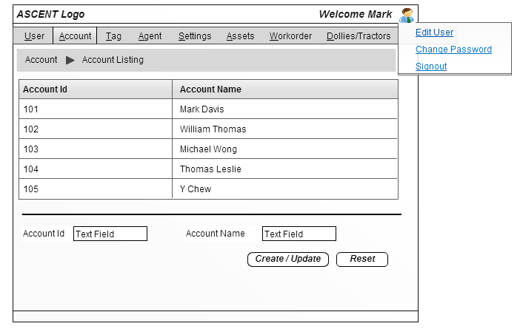
Figure 7: Account Screen
Business Rules
    - Once the user click on the Account menu, the system will display the available account list.
    - System will check the ACL configuration to display the screen in either “Read/View” or “Edit” mode.
    - By default system will provide an option to the user to create a new account on below of the account grid.
    - System will also provide an option to update the existing the account information by clicking the particular account information in the grid anywhere.
    - Once the user provide all the necessary details and click on the “Create / Update” button, system will trigger a call to persist / update the account information in the database.
    - System will validate if the account Id exist or not,
      - If YES,
        - System will trigger the update method to update the account information with the associated account id.
        - After successful update, success message “Account [Account Name] updated successfully” will be displayed.
      - If NO,
        - System will check the account name already exist or not,
          - If YES, system will throw a user readable error message as “Account already Exist” and will restrict the user.
          - If NO, system will initiate the data persistent for account.
          - After successful creation, success message “Account [Account Name] created successfully” will be displayed along with the account ID.
Exit Criteria
User can click any other menus in the screen to leave the “Account” screen.

Settings
- Access Master
This module will describe the menu group and menu item addition, update and view.
Entry Criteria
User click on the “Access Master” sub menu in the “Setting” tab in the menu bar, based on the ACL configuration system will load the screen to the user.
UI Screens
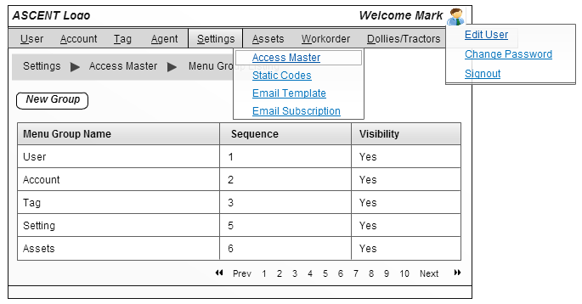
Figure 8: Menu Group List
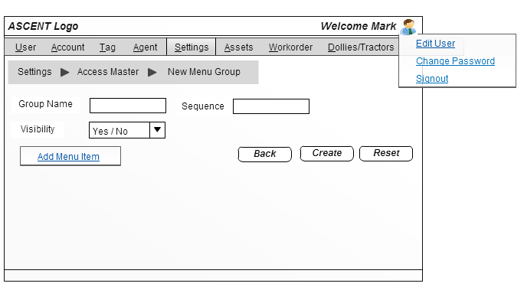
Figure 9: Add Menu Group
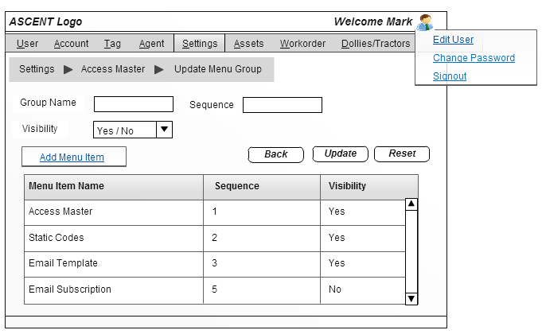
Figure 10: Update Menu Group
Business Rules
      - Once the user click on the “Access Master” submenu under the Setting menu in the menu bar, the system will load the screen to the user.
    - System will check the ACL configuration to display the screen in either “Read/View” or “Edit” mode.
      - System will display the available Menu Group information in the listing grid.
    - System will provide an option for the user to create a new user by clicking on the “New Group” button on top of the user listing grid.
    - System will also provide an option to update the existing the menu group information by clicking the particular menu group information in the grid anywhere.
Create New User Group
    - Once the user click on the “New Group” button in the listing screen, system will redirect to the menu group creation screen to create a new menu group.
    - Once the mandatory fields are filled, the system will trigger a call to persist the new menu group information in the database.
    - System will provide an option to create the menu item and associated to newly created group.
    - By clicking “Add Menu Item” link in the screen, system will redirect the user to create the new menu item under this group.
    - Once the user create the menu item, menu item listing grid will be displayed in the screen, from that user can able to view the list of menu item under this group.
    - System will provide an option to update the menu item.
    - Once the user click on the menu information in grid anywhere, system will redirect the user to menu item screen to update the menu item information.
Update Menu Group
    - Once the user click on the particular menu group information in the grid, system will redirect the user to the “Update Menu Group” screen.
    - System will load the available menu item list in the grid along with the menu group information.
    - System will provide an option to create the menu item and associated to newly created group.
    - System will also provide an option to update the menu item information under this group.
Exit Criteria
User can click any other menus in the screen to leave the “Access Master” screen.

- Static codes
This module will describe the static code addition, update and view.
Entry Criteria
User click on the “Static Codes” sub menu in the “Setting” tab in the menu bar, based on the ACL configuration system will load the screen to the user.
UI Screens
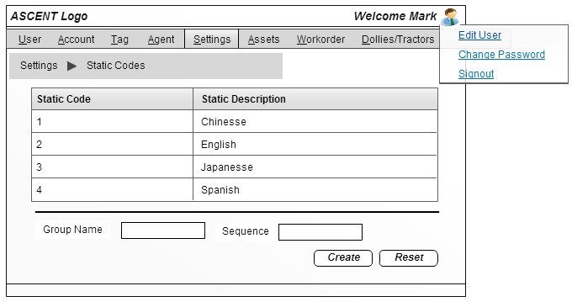
Figure 11: Static Code
Business Rules
      - Once the user click on the “Static Codes” submenu under the Settings menu in the menu bar, the system will load the screen to the user.
    - System will check the ACL configuration to display the screen in either “Read/View” or “Edit” mode.
    - By default system will provide an option to the user to create, new static codes on below of the grid.
    - System will also provide an option to update the existing the static codes information by clicking the particular account information in the grid anywhere.
    - Once the user provide all the necessary details and click on the “Create / Update” button, system will trigger a call to persist / update the static codes information in the database.
Exit Criteria
User can click any other menus in the screen to leave the “Static Codes” screen.
- Email Template
- Email Subscription

Assets
- Dolly’s
System will provide an option to create/ update the dolly’s information based on the ACL configuration, below is the list of operation can be performed in this module.
  - Dolly List
  - Create / Update Dolly
  - Load Existing Dolly
Entry Criteria
User click on the “Dolly’s” sub menu in the “Asset” tab in the menu bar, based on the ACL configuration system will load the screen to the user.
UI Screens
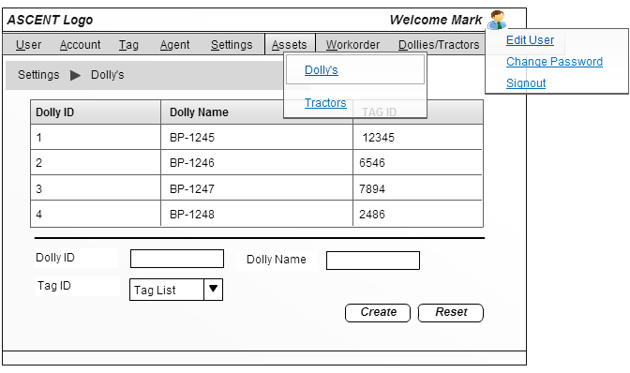
Figure 12: Dolly List

Business Rules
      - Once the user click on the “Dolly” submenu under the Asset menu bar, the system will load the screen to the user.
    - System will check the ACL configuration to display the screen in either “Read/View” or “Edit” mode.
      - System will display the available dolly’s information in the listing grid.
    - By default system will provide an option to the user to create new dolly information on below of the dolly grid.
    - System will also provide an option to update the existing the dolly information by clicking the particular dolly information in the grid anywhere.
    - Once the user provide all the necessary details and click on the “Create / Update” button, system will trigger a call to persist / update the dolly information in the database.
      - System will validate if the dolly id already exists or not,
        - If YES,
          - System will trigger the update method to update the dolly information with the associated dolly id.
          - After successful update, success message “Dolly [Dolly Name] updated successfully” will be displayed along with the Dolly ID
        - If NO,
          - System will initiate the data persistent for dolly.
          - After successful creation, success message “Dolly [Dolly Name] created successfully” will be displayed along with the Dolly ID
Exit Criteria
User can click any other menus in the screen to leave the “Dolly” screen.
- Tractors
System will provide an option to create/ update the tractor information based on the ACL configuration, below is the list of operation can be performed in this module.
  - Tractors List
  - Create / Update Tractors
  - Load Existing Tractors
Entry Criteria
User click on the “Tractor” sub menu in the “Asset” tab in the menu bar, based on the ACL configuration system will load the screen to the user.
UI Screens
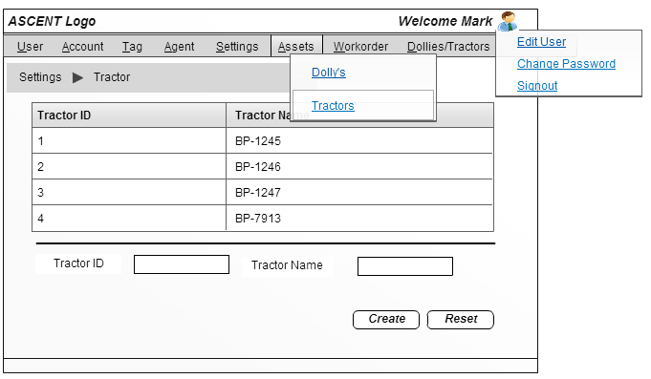
Figure 13: Tractor List
Business Rules
      - Once the user click on the “Tractor” submenu under the Asset menu bar, the system will load the screen to the user.
    - System will check the ACL configuration to display the screen in either “Read/View” or “Edit” mode.
    - By default system will provide an option to the user to create new tractor information on below of the tractor grid.
    - System will also provide an option to update the existing the tractor information by clicking the particular tractor information in the grid anywhere.
    - Once the user provide all the necessary details and click on the “Create / Update” button, system will trigger a call to persist / update the tractor information in the database.
      - System will validate if the tractor id already exists or not,
        - If YES,
          - System will trigger the update method to update the tractor information with the associated tractor id.
          - After successful update, success message “Tractor [Tractor Name] updated successfully” will be displayed along with the Dolly ID
        - If NO,
          - System will initiate the data persistent for Tractor.
          - After successful creation, success message “Tractor [Tractor Name] created successfully” will be displayed along with the Dolly ID
Exit Criteria
User can click any other menus in the screen to leave the “Tractor” screen.

Tag
System will provide an option to create/ update the tag information based on the ACL configuration, below is the list of operation can be performed in this module.
  - Tag List
  - Create / Update Tag
  - Load Existing Tag
Entry Criteria
User click on the Tag tab in the menu bar, based on the ACL configuration system will load the screen to the user.
UI Screens
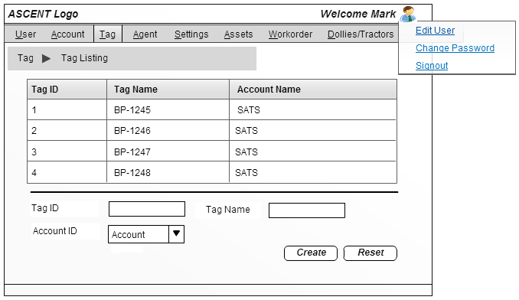
Figure 14: Tag List
Business Rules
      - Once the user click on the “Tag” menu in the menu bar, the system will load the screen to the user.
      - System will check the ACL configuration to display the screen in either “Read/View” or “Edit” mode.
      - By default system will provide an option to the user to create a new tag on below of the tag grid.
      - System will also provide an option to update the existing the tag information by clicking the particular account information in the tag anywhere.
      - Once the user provide all the necessary details and click on the “Create / Update” button, system will trigger a call to persist / update the tag information in the database.
      - System will validate if the tag id already exists or not,
        - If YES,
          - System will trigger the update method to update the tag information with the associated tag id.
          - After successful update, success message “Tag [Tag Name] updated successfully” will be displayed along with the Tag ID
        - If NO,
          - System will initiate the data persistent for Tag.
          - After successful creation, success message “Tag [Tag Name] created successfully” will be displayed along with the Tag ID
Exit Criteria
User can click any other menus in the screen to leave the “Tag” screen.

Agent / Agent Location
System will provide an option to create/ update the tag information based on the ACL configuration, below is the list of operation can be performed in this module.
  - Agent List
  - Create / Update Agent / Agent Location
  - Load Existing Agent / Agent Location
Entry Criteria
User click on the Agent tab in the menu bar, based on the ACL configuration system will load the screen to the user.
UI Screens
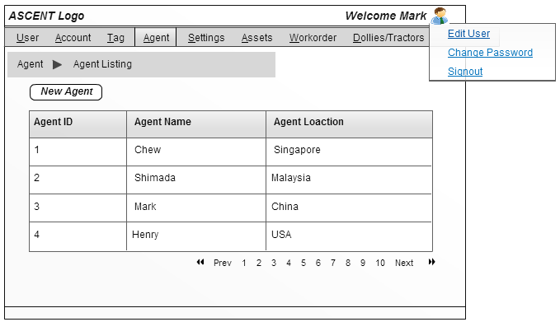
Figure 15: Agent List
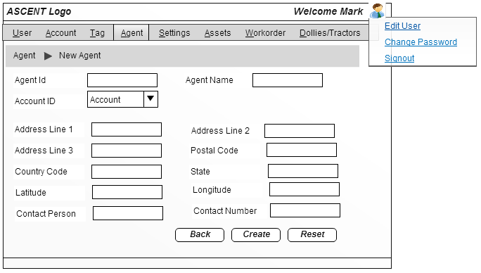
Figure 16: New Agent
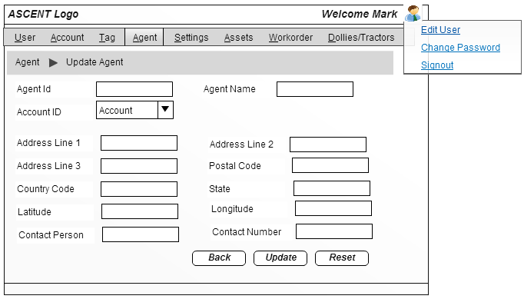
Figure 17: Agent Update
Business Rules
      - Once the user click on the “Agent” menu in the menu bar, the system will load the screen to the user.
      - System will check the ACL configuration to display the screen in either “Read/View” or “Edit” mode.
      - System will provide an option for the user to create a new agent by clicking on the “New Agent” button on top of the agent listing grid.
      - System will also provide an option to update the existing the agent information by clicking the particular agent information in the grid anywhere.
      - Once the user click on the “New Agent” button in the listing screen, system will redirect to the agent creation screen to create a new agent.
      - System will capture the agent location along with the agent information.
      - Once the mandatory fields are filled, the system will trigger a call to persist the new agent information in the database.
      - After successful user account creation, success message “Agent [Agent Name] created successfully” will be displayed along with the agent ID.
      - System will provide an option to return back to the “User Listing” screen.
      - Once the user click on the particular agent information in the grid, system will redirect the user to the “Update Agent” screen.
      - System will load the agent information based on the agent Id.
      - Once the mandatory fields are filled, the system will trigger a call to update the agent information in the database.
      - After successful update, success message “Agent [Agent Name] updated successfully” will be displayed.
      - System will provide an option to return back to the “User Listing” screen.
Exit Criteria
User can click any other menus in the screen to leave the “Agent” screen.

Transactional Module
This module will describe the transaction details for Work Order, Dollies & Tractors in detailed with business rules, UI screens, and entry & exit criteria.

Work Order
System will provide an option to create the work order and track the work order information, below are the list of operation performed in this module.
  - Work Order List
  - Work Order Creation
  - View Work Order information
Entry Criteria
User click on the Workorder tab in the menu bar, based on the ACL configuration system will load the screen to the user.
UI Screens
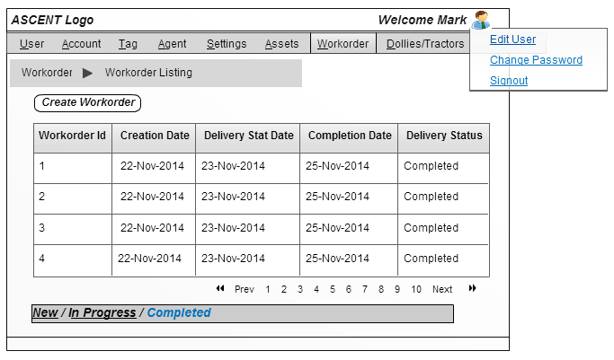
Figure 18: Workorder Listing 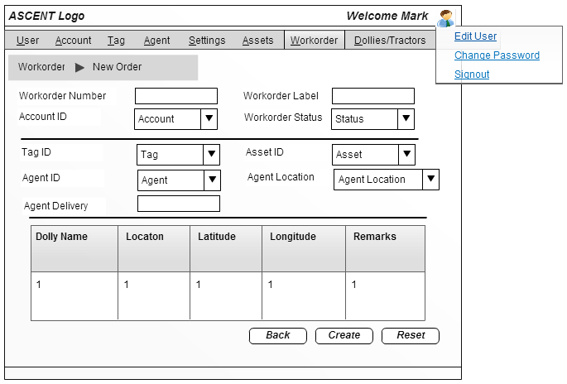
Figure 19: Word Order Creation
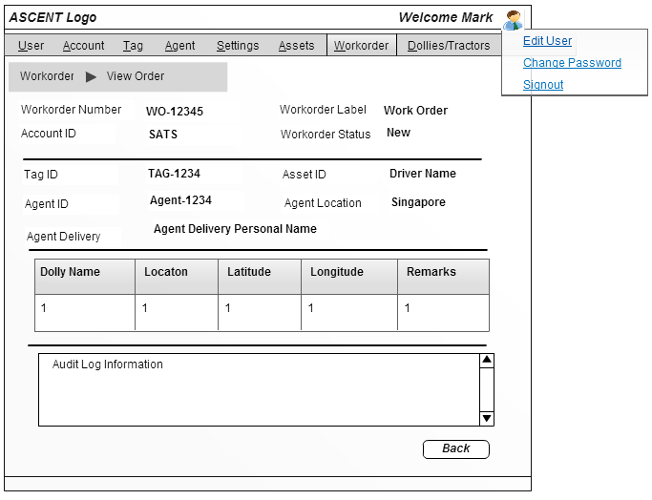
Figure 20: View Workorder
Business Rules
      - Once the user click on the “Workorder” menu in the menu bar, the system will load the screen to the user.
      - System will check the ACL configuration to display the screen in either “Read/View” or “Edit” mode.
      - System will provide an option for the user to create a new work order by clicking on the “Create WorkOrder” button on top of the work order listing grid.
      - System will also provide an option to view the work order detail information by clicking the particular work order information in the grid anywhere.
Work Order List
      - System will provide to change the filter by clicking the “Status” link in below of the work order listing grid.
      - By default system will load the “New” status information in the work order listing grid.

Create New Work Order
      - Once the user click on the “Create WorkOrder” button in the listing screen, system will redirect to the work order screen creation screen to create a new order.
      - System will capture the Agent Information (Agent Id), Tag Information (Tag Id), Asset Information (Asset Id), Agent Location Information (Agent Location Id) and Agent Delivery Personnel (Agent Delivery Personnel Id) information along with the list of dollies associated with the Work Order.
      - Once the user provides all the above information system will trigger a call to persist the captured information in the database against the system generated “Workorder ID”.
      - After successful order creation, success message “Order created successfully” will be displayed along with the Workorder ID.
      - System will provide an option to return back to the “WorkOrder Listing” screen.
View Work Order
      - Once the user click on the particular work order information in the grid, system will redirect the user to the “WorkOrder” screen in view mode.
      - System will load the order information based on the Workorder Id.
      - System will also load the audit history of the Work Order.
Order Life Cycle
Figure 21: Order Life Cycle
New
In Progress
Completed

Exit Criteria
User can click any other menus in the screen to leave the “Workorder” screen.

Dolly’s / Tractors
This module will describe the Dolly’s and Tractors information.
Entry Criteria
User click on the Dolly’s/Tractors tab in the menu bar, based on the ACL configuration system will load the screen to the user.
UI Screens
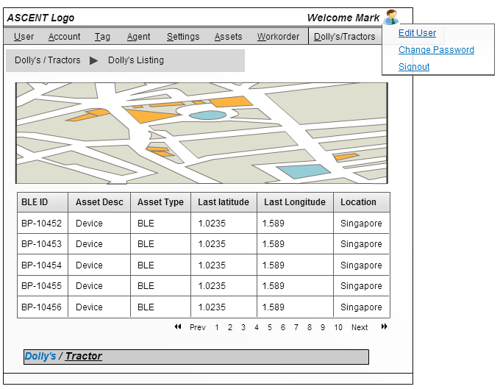
Figure 22: Dolly/Tractor List
Business Rules
      - Once the user click on the “Dolly’s/Tractors” menu in the menu bar, the system will load the screen to the user.
      - System will provide an option to view the available dolly’s list in the grid.
      - By default system will load the dolly’s list, and user has option to change the “Tractors” list by clicking the tractor link on below of the grid.
      - System will also provide an option to filter to customize the grid.
      - System will show the dolly’s / Tractors pin in the Google Map on top of the grid.
      - Based on the filter condition, system will reload the map in 2 mins interval.
      - System will also provide an option to view the dolly’s / Tractors information with audit history by clicking the particular information in the grid in separate screen.
Exit Criteria
User can click any other menus in the screen to leave the “Dolly’s/Tractors” screen.

Mobile Interaction Module - Web Service List
This module will describe the list of API’s exposed in the system for interacting with mobile app. It will cover the Request pattern for individual API’s, below are the list of API’s has been exposed.
- Login
- Workorder List
- Workorder Status
- Photo Upload
- Listing Assets
URL to be used to call the Service:
- aq/requestJson for all the list operations.
- as/requestJson rest of the operations.
- Login
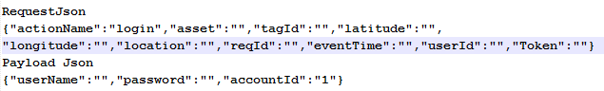
Figure 23: Login JSON
- Workorder List
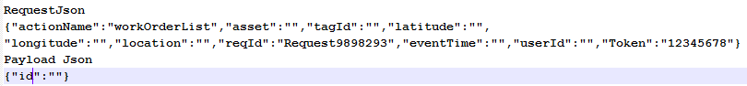
Figure 24: Workorder List JSON
- Workorder Status
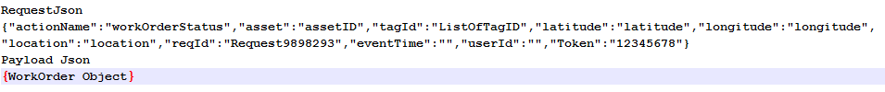
Figure 25: Workorder Status JSON
- Listing Assets
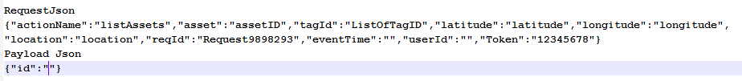
Figure 26: Asset List JSON

- Photo Upload
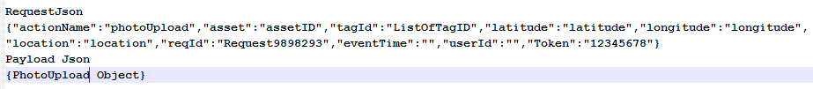
Figure 27: Photo Upload JSON

Reports
To be discussed.

Technical Scope
This section will cover the overall design of the application and it will provides the detailed description of each and every module in various diagrams like class and sequence.

Technical Architecture
// to be Drawn

Technical Description

Login Module
Request & Payload JSON
Figure 28: Login - Request & Payload JSON
Class Diagram
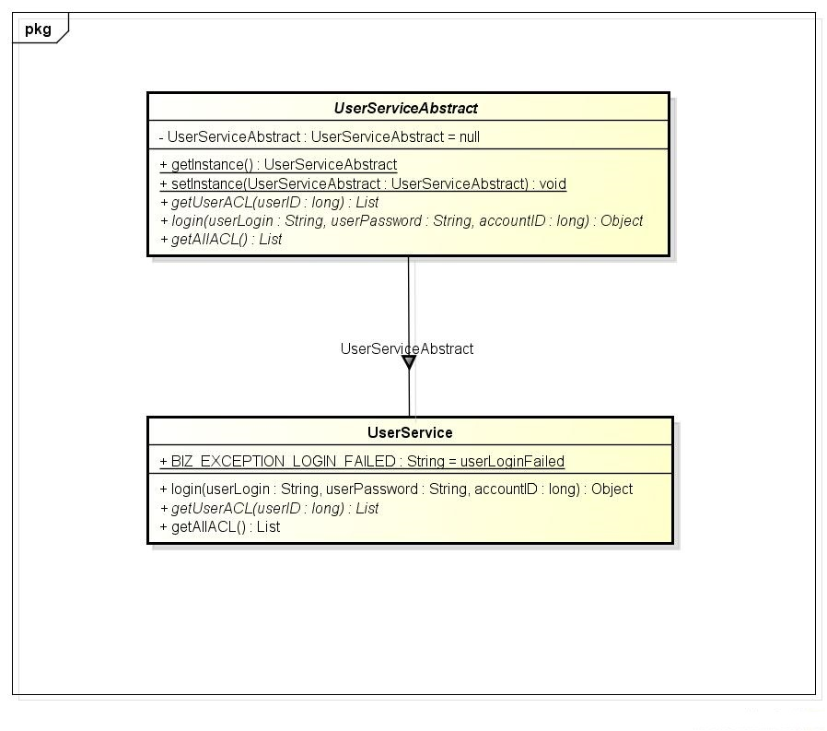
Figure 29: Login Class Diagram
Sequence Diagram
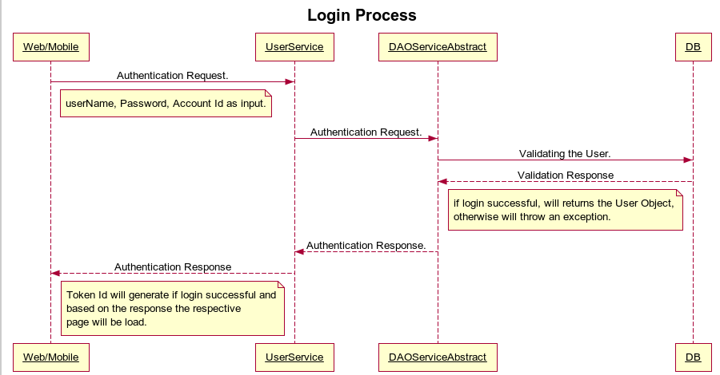
Figure 30: Login Sequence Diagram

Management Setup Module
- User
- User Listing
Query & Payload JSON
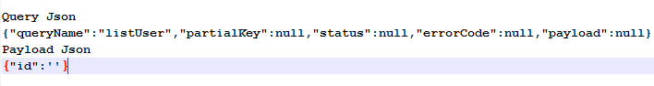
Figure 31: List User JSON
Class Diagram
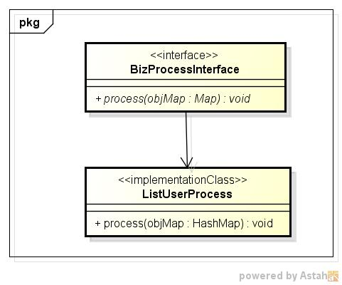
Figure 32: User Listing Class Diagram
Sequence Diagram
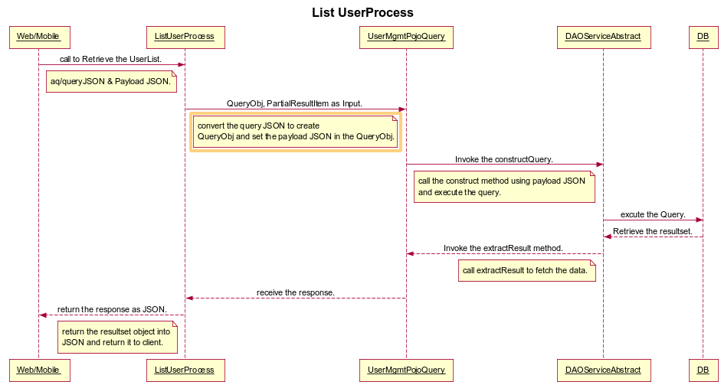
Figure 33: User List Sequence Diagram
- New User Creation
Request & Payload JSON
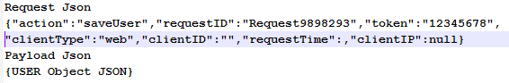
Figure 34: New User JSON
Class Diagram
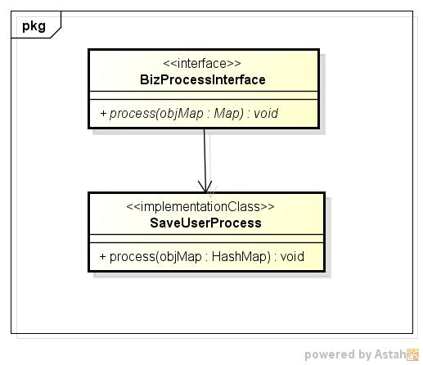
Figure 35: New User Class Diagram
Sequence Diagram
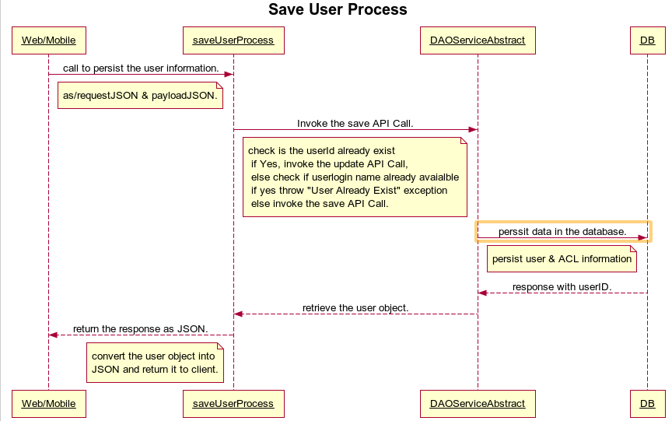
Figure 36: New User Sequence Diagram
- Update User
Request & Payload JSON
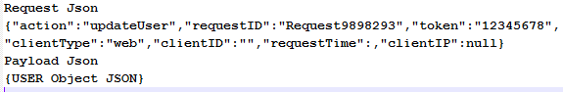
Figure 37: Update User JSON
Class Diagram
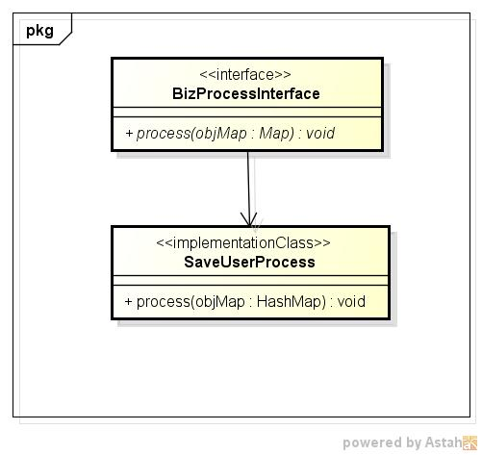
Figure 38: Update User Class Diagram
Sequence Diagram
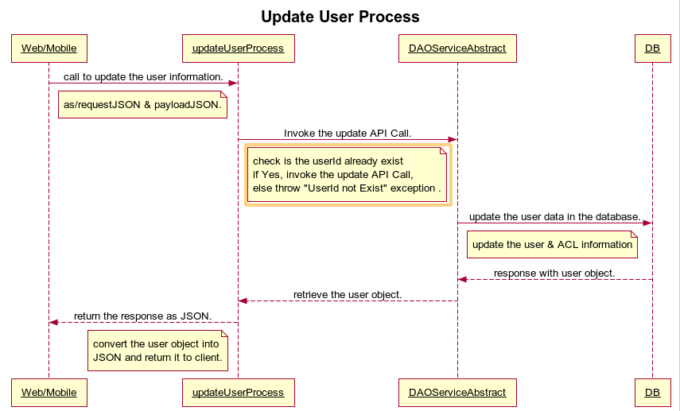
Figure 39: Update User Sequence Diagram
- Enable / Disable User
Request & Payload JSON
Refer the Update user JSON
Class Diagram
Refer the Update User class Diagram
Sequence Diagram
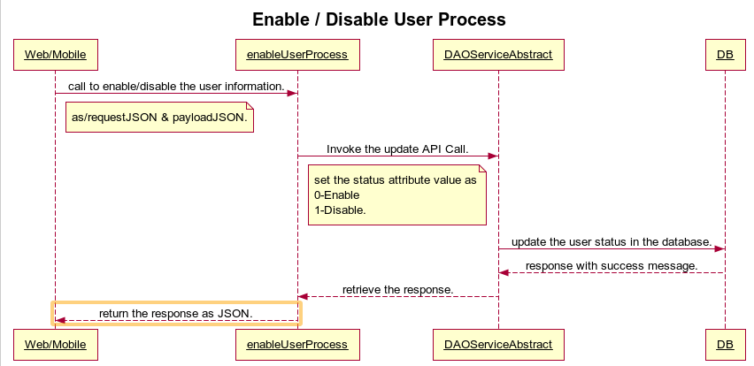
Figure 40: Enable/Disable User Sequence Diagram
- Load User
Request & Payload JSON
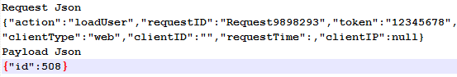
Figure 41: Load User JSON

Class Diagram
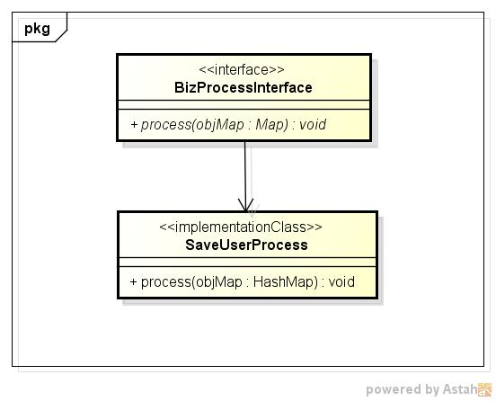
Figure 42: Load User Class Diagram

Sequence Diagram
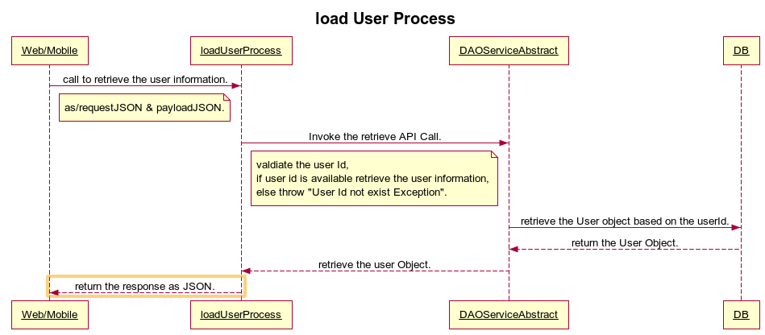
Figure 43: Load User Sequence Diagram

- Account
Request & Payload JSON
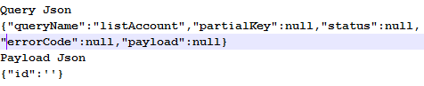
Figure 44: List Account JSON
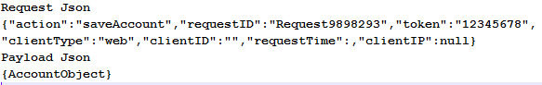
Figure 45: Save Account JSON
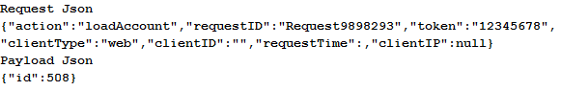
Figure 46: Load Account JSON
Class Diagram
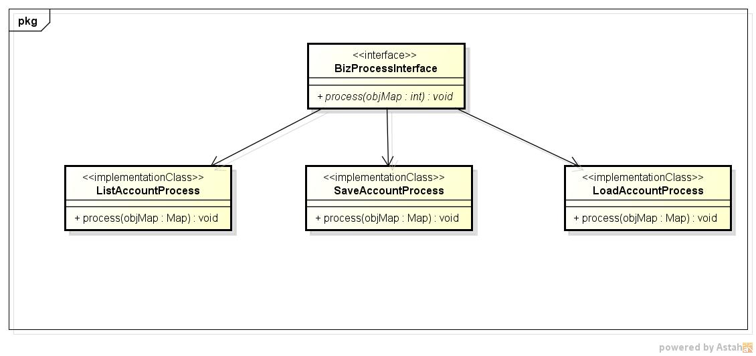
Figure 47: Account Class Diagram
Sequence Diagram
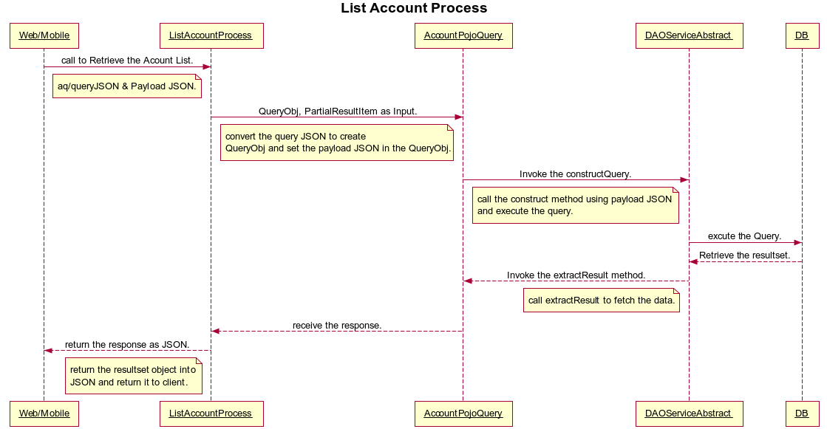
Figure 48: Account List Sequence Diagram
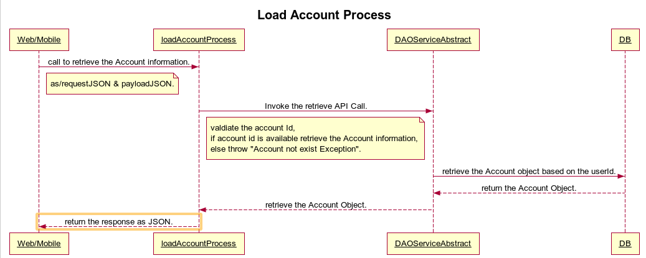
Figure 49: Load Account Sequence Diagram
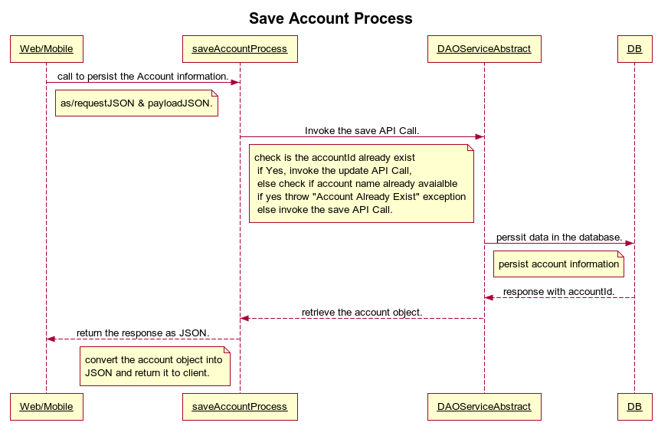
Figure 50: Save/Update Account Sequence Diagram
- Settings
  - Access Master
Class Diagram
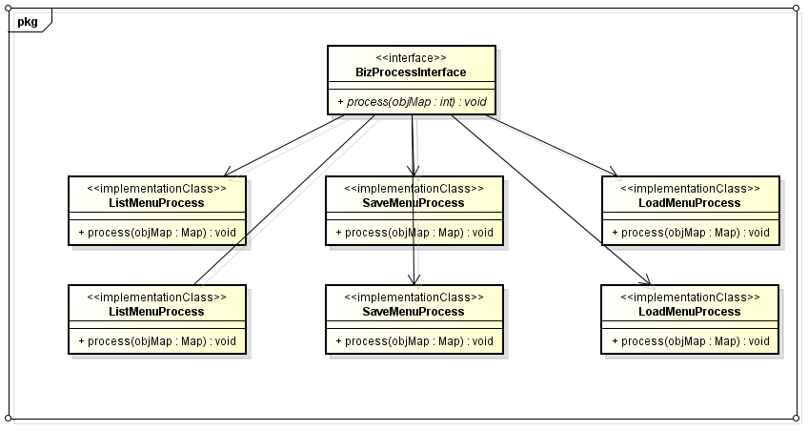
Figure 51: Menu Group & Menu Item Class Diagram
  - Static codes
Class Diagram
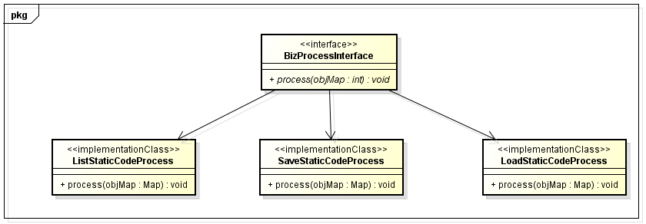
Figure 52: Static Code Class Diagram

  - Email Template
  - Email Subscription
- Assets
  - Dollies
Class Diagram
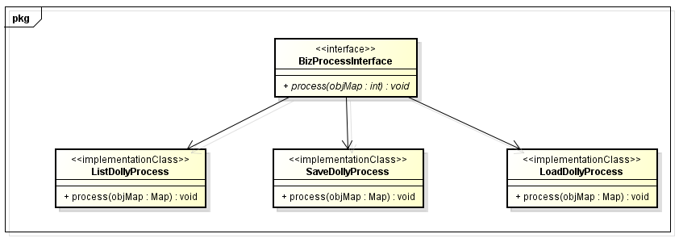
Figure 53: Dolly Class Diagram
  - Tractors
Class Diagram 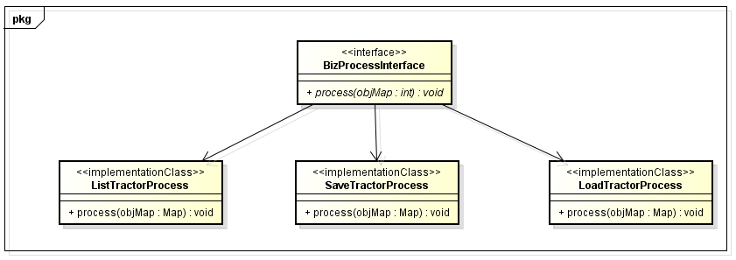
Figure 54: Tractor Class Diagram
- Tag
Class Diagram
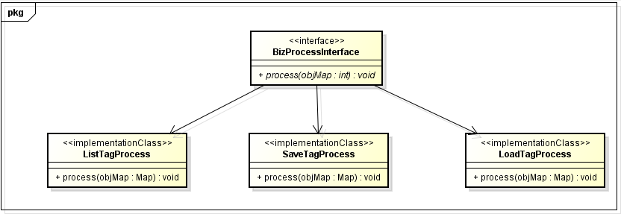
Figure 55: Tag Class Diagram
- Agent / Agent Location
Class Diagram
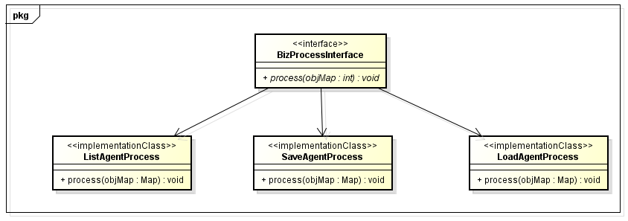
Figure 56: Agent Class Diagram

Transactional Module
- Work Order
Class Diagram
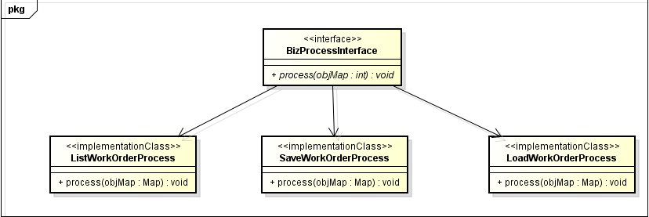
Figure 57: WorkOrder Class Diagram
- Dollies / Tractors
Class Diagram
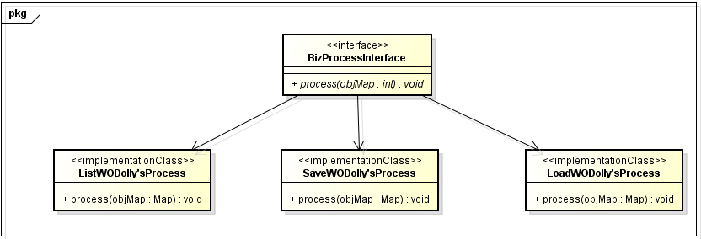
Figure 58: Transactional (Dolly's/Tractor) Class Diagram

Out of Scope

Assumptions & Dependencies

